**Lead Service Line Inventory Website Content**

**Lead Service Line Questionnaire**

The Lead Service Line Replacement and Notification Act (Public Act 102-0613) mandates that all public water suppliers in Illinois create a comprehensive water service line material inventory for all properties supplied with water in the community. To meet this mandate, the Village of Posen needs your help collecting information on the material of the water service line in your house.

Water service lines are the pipes along your property that run from the Village’s watermain to the water meter inside your home (see diagram below). Common water service line materials found in homes include copper, lead, galvanized steel, and plastic. Congress banned the use of lead service line pipes in 1986 to protect public health. **However, if your house was built before 1986, your water service line may be made out of lead.** Please also note that plumbing products sold between 1986 and 2014 were still allowed to contain up to 8% of lead content by weight. **Therefore, there is still potential for your plumbing to have lead if your house was constructed between 1986 and 2014.**

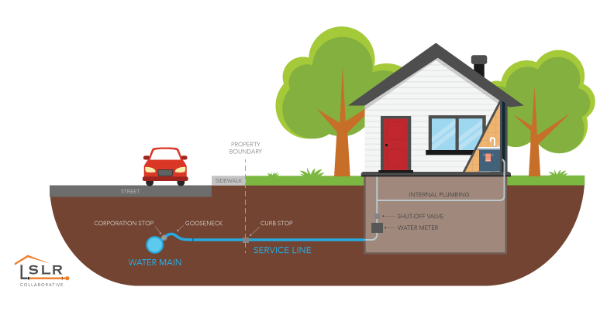

Photo Source: <https://www.lslr-collaborative.org/intro-to-lsl-replacement.html>

To identify the material of your water service line, please follow the step-by-step instructions in the pipe identification brochure below. Alternatively, you can contact a licensed plumber to identify the material for you.

Once you know the material of your water service line, please fill out the questionnaire to report your results to the Village of Posen by scanning the QR Code below with your mobile device. Alternatively, you can click on the link below. The questionnaire will require you to upload photos of your water service line for Village staff to review. Taking a photo with your mobile phone or tablet is a convenient way to upload your photos into the questionnaire.



**Filling out the questionnaire is required if your house or building was built before 1986. As a precaution, we strongly encourage all residents to fill out the questionnaire to verify the material of their water service line.**

**Public Informational Meeting**

The Village of Posen will hold two public informational meetings to walk through the questionnaire and to answer questions that residents and building owners may have.

**November 15, 2023 at 6:00pm**

**Spanish meeting, November 16,2023 at 6:00pm**

**Both will be held at the Posen Community Center, 14401 S Campbell Ave, Posen, IL.**

**Why are Lead Service Lines a Public Health Concern?**

Lead is a toxic metal that is harmful to human health when inhaled or swallowed. If your home has a lead service line, the lead can leach into your drinking water when the lead pipes experience corrosion. Corrosion is caused by a chemical reaction between the water and your plumbing. There are several factors that can impact the amount of lead entering your water from your plumbing, including water temperature, pipe condition, the water chemistry (such as acidity or alkalinity), and more.

Lead can accumulate in our bodies over time and is stored within the bones. Lead exposure can result in several adverse health effects. Children are especially at risk because even low levels of lead in the bloodstream can cause damage to the nervous system, learning disabilities, impaired hearing, slowed growth, behavioral issues, and anemia. Pregnant women are also at high risk, as lead exposure can cause premature birth and reduced fetus growth. Lead exposure in adults can cause increases in blood pressure, reproductive issues, and kidney issues.

**What Can I Do to Reduce My Exposure to Lead?**

The best way to reduce your exposure to lead is by identifying the plumbing fixtures in your home which contain lead and having them replaced. This includes the faucets, fittings, pipes, and valves inside your house as well as the water service line that enters your house. Please note that plumbing products sold before 2014 were allowed to contain up to 8% of lead content by weight. On January 4, 2014, a new law went into effect that required plumbing products to contain very low levels of lead (no more than 0.25% by weight). Therefore, there is still potential for your plumbing to have lead if your house was constructed between 1986 and 2014.

The Lead Service Line Notification Act now requires public water suppliers in Illinois, including the Village of Posen, to replace all lead service lines within the community from the watermain to the water meter in the home. The Village of Posen will be required to replace between 6% to 7% of the lead service lines annually. The Village will be required to prepare a lead service line replacement program for the community, but this effort will require resident cooperation so the Village can compile a complete inventory of all homes with confirmed lead service lines. This is why completing the lead service line questionnaire is so important.

If you have lead plumbing or a lead service line in your house, but cannot have it replaced at this time, below are some steps you can take to reduce exposure to lead in drinking water.

* **Run your water to flush out the lead before drinking.** If you haven’t used water in your house for several hours, run your water to flush out the pipes before using the water for drinking or cooking.
* **Always use cold water for drinking, cooking, and baby formula.** Never use water from the hot water tap for cooking or drinking. Water from the hot water tap has higher lead levels than water from the cold tap. If you need hot water, take water from the cold tap, and heat it on your stove. Remember that boiling water does not remove lead.
* **Remove and clean your faucet aerator regularly.** The faucet aerator is the screen located on your faucet where the water comes out. Over time, lead particles and other debris can collect on the aerator and can cause lead to leach into your water. Remove and clean your aerator regularly. While cleaning your aerator, run the water through your faucet to flush out the debris. Once clean, reinstall the aerator.
* **Consider using a water filter certified to remove lead.** The water filter should be certified under NSF/ANSI Standard 53 to remove lead. Follow the filter instructions for proper filter installation and for filter cartridge replacement requirements. Avoid using cartridges that have expired. For more information on filters certified to reduce lead see link below: <https://www.epa.gov/sites/default/files/2018-12/documents/consumer_tool_for_identifying_drinking_water_filters_certified_to_reduce_lead.pdf>
* **Use an alternative water source for drinking and cooking.**

**Questions**

If you have any questions or concerns, please contact the Village of Posen (708)-385-0139

**Additional Resources to Learn More**

If you are interested in learning more about lead, lead service lines, and/or Illinois laws for lead service lines, please see the links below for additional information.

U.S. Environmental Protection Agency: Basic information about lead in drinking water

<https://www.epa.gov/ground-water-and-drinking-water/basic-information-about-lead-drinking-water>

U.S. Environmental Protection Agency: Infographic on lead in drinking water

<https://www.epa.gov/sites/default/files/2017-08/documents/epa_lead_in_drinking_water_final_8.21.17.pdf>

U.S. Environmental Protection Agency: How to Identify Lead Free Certification Marks for Plumbing Products.

<https://nepis.epa.gov/Exe/ZyPDF.cgi?Dockey=P100LVYK.txt>

Illinois Department of Health: Lead Service Lines and Illinois Laws

<https://dph.illinois.gov/topics-services/environmental-health-protection/lead-in-water/lead-service-lines.html>

Illinois Environmental Protection Agency: Lead Service Line Inventory Information

<https://epa.illinois.gov/topics/drinking-water/public-water-users/lead-service-line-information.html>

State of Illinois Lead Service Line Notification Act (Public Act 102-0613)

<https://www.ilga.gov/legislation/publicacts/102/102-0613.htm>